

CALIBRATION PROCEDURE - DeltaTRAK 11000

DIGITAL PROBE THERMOMETER

PLEASE NOTE: Performing this procedure voids all warranties regarding calibration and DeltaTRAK assumes no liability for the accuracy of products calibrated by the customer.

Tools Needed:

- 16 ounce cup (disposable plastic preferred)
- Crushed ice
- Calibrated NIST Traceable Reference Thermometer (If available)
- Flat screwdriver
- Calibration tool( Figure-A)

1. Slight out the calibration tool in the back of the digital probe thermometer,
See Figure-B.

2. Remove the small flat screw from the center of the pocket clip on the back of the
digital probe thermometer using flat screwdriver. be careful not to lose the rubber
O-Ring which is needed to make the seal waterproof. the temperature adjustment
Potentiometer is inside. Use the calibration tool in the back of the digital probe thermometer.

- Mix thoroughly crushed ice in water (60% ice and 40% water) in plastic cup.
You can use the thermometer to be calibrated to do this and it will cool the metal
tip faster. Mix for 1 minute and let sit for 5 minutes.

- Mix again with probe for 30 seconds. Insert Reference Thermometer, if
available, and probe to be calibrated in water approximately 3” deep and allow
to sit for 5 minutes. Stir ice and water using probe(s), for 30 seconds.

- Using the calibration tool screwdriver in the back of the digital probe thermometer and adjust the temperature through the hole of the probe to be calibrated until it matches the Reference Thermometer ± .1°F or °C.
Remove the screwdriver, mix the ice and water with the probe to be calibrated for
30 seconds, and verify that the temperature still matches the Reference
Thermometer reading ± .1°F or °C. If the reading is not the same, re-adjust the
temperature reading of the probe and repeat verification, adjusting and mixing until
the reading is the same.

- If no Reference Thermometer is available complete steps 1- 2. Mix the ice and water with the probe to be calibrated for 30 seconds. Insert the probe into the ice water approximately 3” and allow it to sit for 5 minutes, Stir the ice and water using the probe, for 30 seconds. Using the calibration tool screwdriver, adjust the temperature reading of the probe to 32°F or 0°C ± .1°F or °C.

- Remove the screwdriver, mix again for 30 seconds and verify that the reading is the same.
- If the reading is not the same, re-adjust the temperature reading of the probe and repeat verification, adjusting and mixing until the reading is the same.

- Replace the rubber O-Ring and then the screw.

DIGITAL PROBE CALIBRATION PROCEDURE FIGURES A, B, C & D.

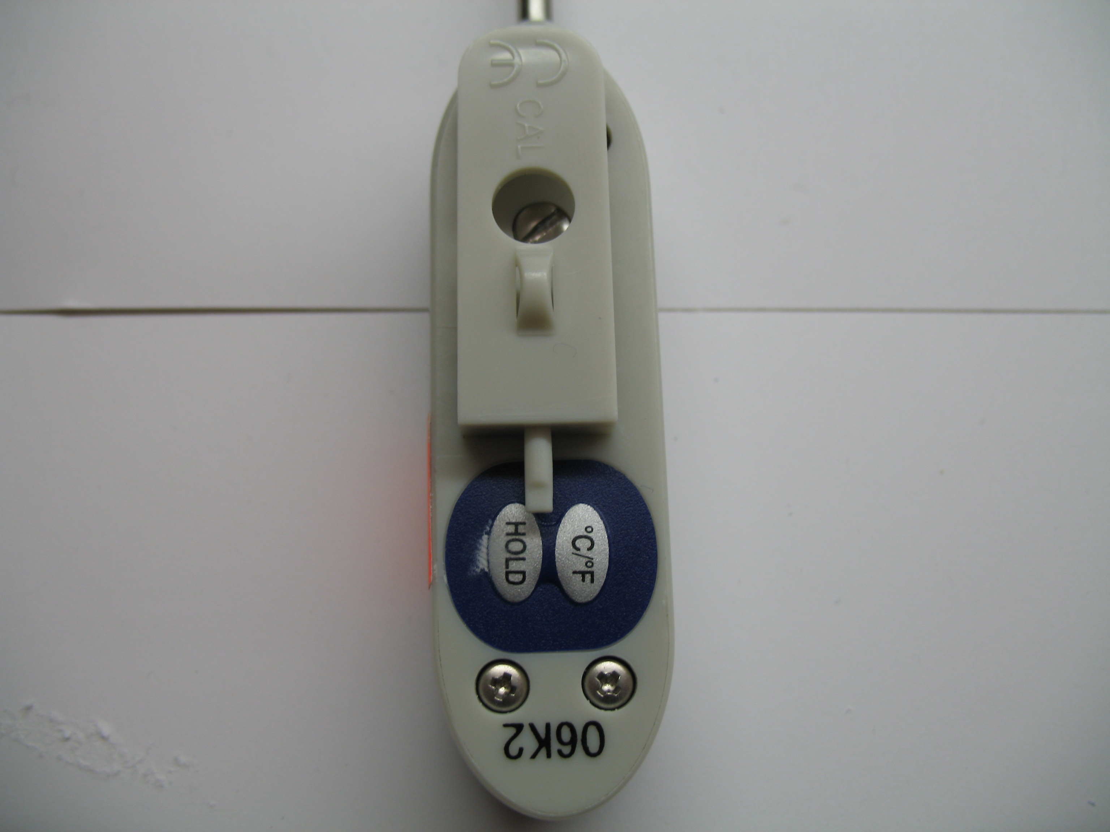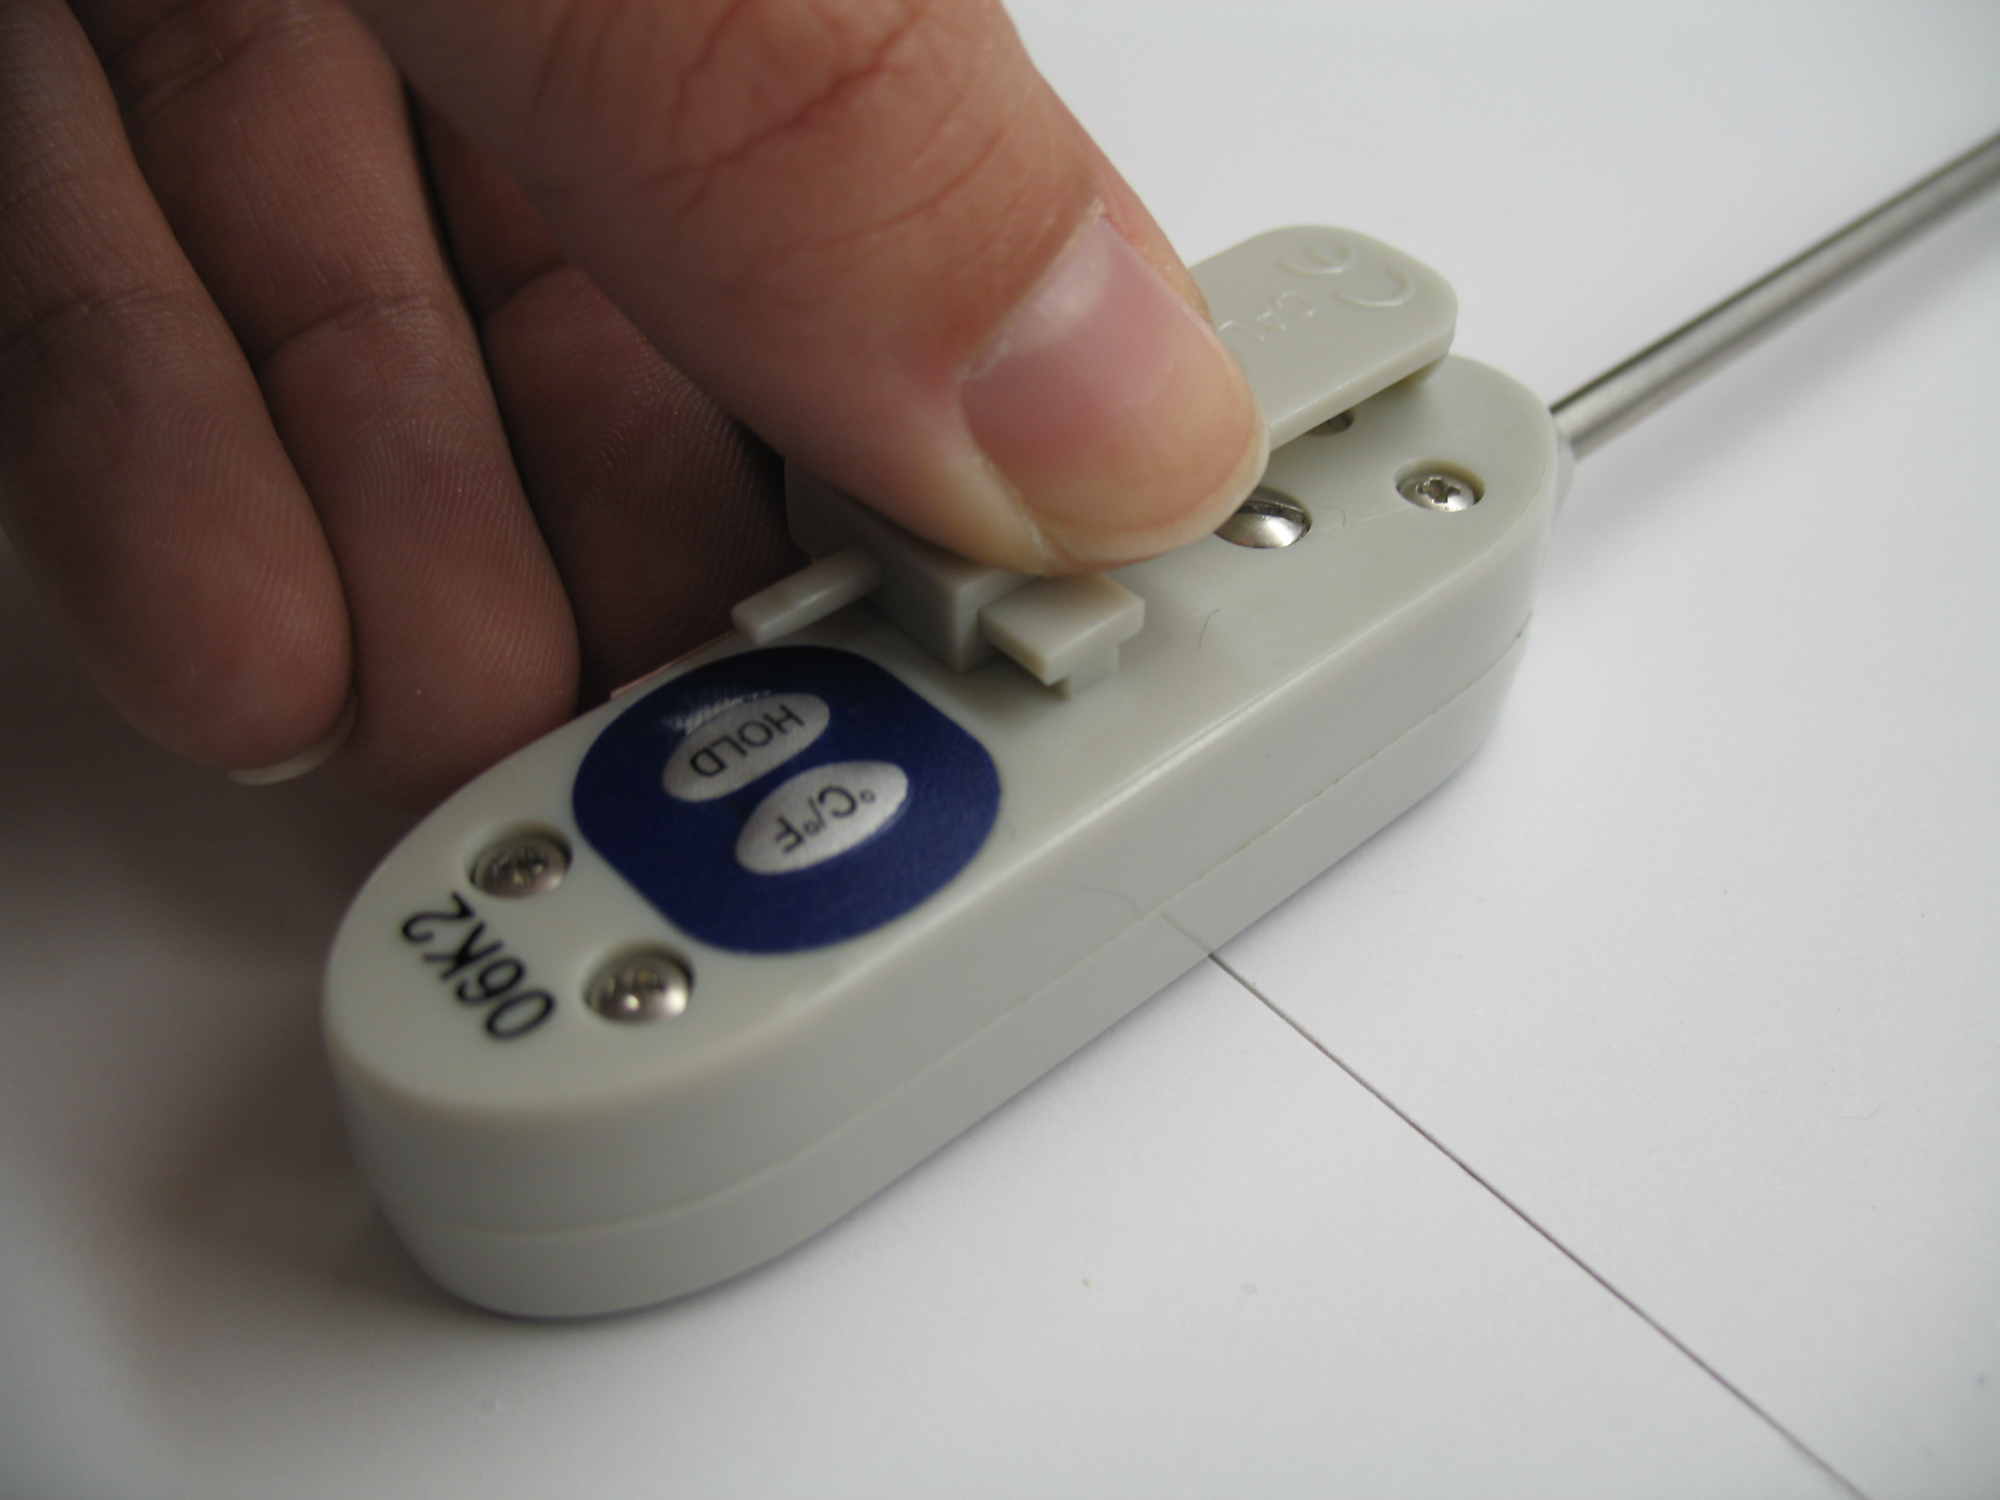

Figure-A Figure-B

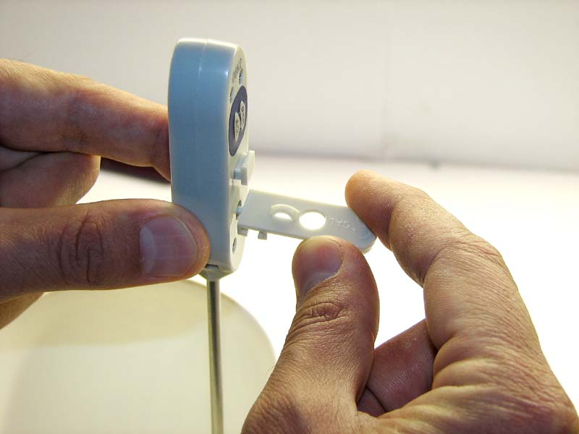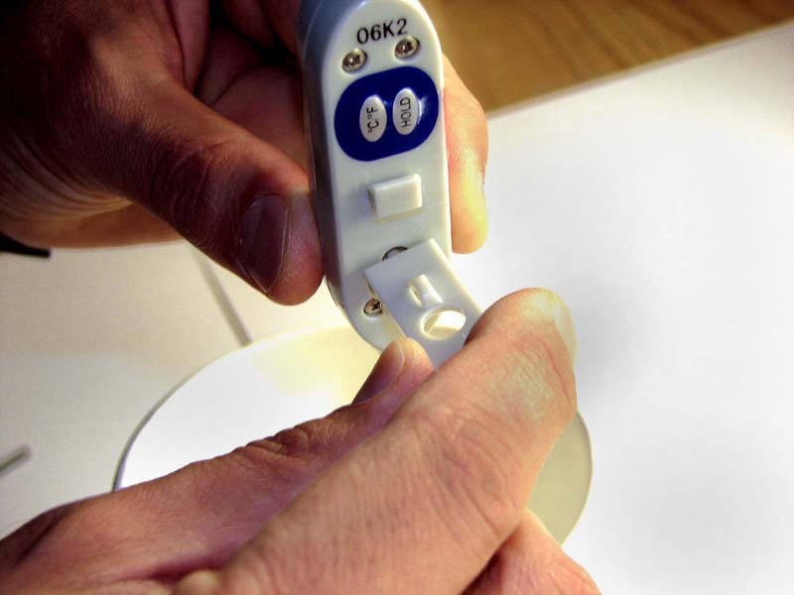

Figure-C Figure-D

